|  |
| --- |
| Mini Games Ltd. |
| COMP305 Final Project |
| External Game Document |
| Version #1.0  All work Copyright © 2016 by Mini Games Ltd.  All rights reserved. |
| **Winnie Chung, Jose Tinoco, Vasyl Milchevskyi** |
|  |

|  |
| --- |
| December 19, 2016 |

## Table of Contents

[Table of Contents 2](#_Toc469346055)

[Version History 2](#_Toc469346056)

[I. Game Overview 3](#_Toc469346057)

[II. Game Play Mechanics 3](#_Toc469346058)

[III. Camera 3](#_Toc469346059)

[IV. Controls 3](#_Toc469346060)

[V. Interface Sketch 3](#_Toc469346061)

[VI. Menu and Screen Descriptions 5](#_Toc469346062)

[VII. Characters 8](#_Toc469346063)

[VIII. Enemies 8](#_Toc469346064)

[IX. Scoring 8](#_Toc469346065)

[X. Sound Index 9](#_Toc469346066)

[XI. Art / Multimedia Index 9](#_Toc469346067)

## Version History

The most updated version history can be found at:

<https://github.com/joetinoco/COMP305-FinalAssignment>

## Game Overview

*The goal of the game is to reach the “exit” of each level in the shortest total time, while avoiding enemies. Falling off ledges and/or getting hit by enemies (or spikes) will decrease the player’s remaining lives.*

## Game Play Mechanics

*The score is decreased for each frame that passes, and the number of lives left decreases each time the player hits an enemy (or spikes). The game ends when there are no lives remaining. Five lives are added when the player reaches the next level (Level 1 to Level 2, Level 2 to Level 3)*

## Camera

*The camera follows the player’s avatar.*

## Controls

*A or left arrow key = move left*

*D or right arrow key = move right*

*W or up arrow key = jump*

## Interface Sketch

Menu Scene (also Game Over/Clear State):

(Re)start button

Title (part 2 of 2)

Tile (part 1 of 2)

Instructions

button

Level 1:

Moving platform (vertical)

Moving platform (horizontal)

Enemy

Enemy

Coin block

Check point



Level 2:

Springboard

Enemy

Coin block

Check point

Enemy



Level 3:

Enemy

Coin block

Moving platform (horizontal)

Check point

Moving platform (vertical)

Springboard

Key

**

## Menu and Screen Descriptions

*Menu Scene:*

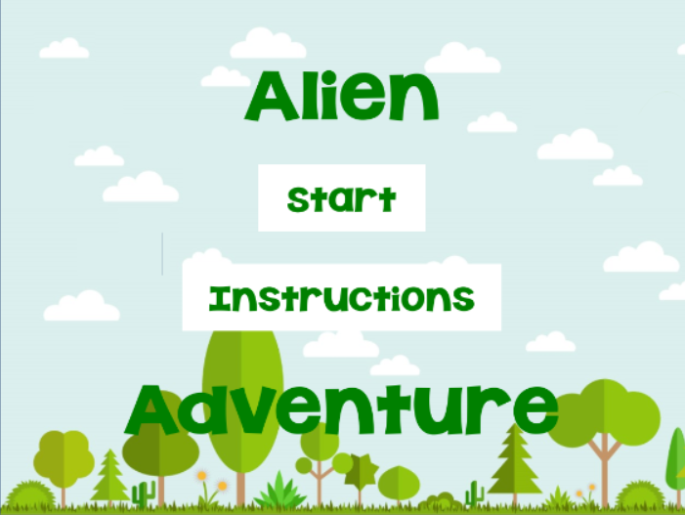

*The menu scene displays the title and start button. When the start button is clicked, the player is brought to the Level1 Scene.*

*Instructions Scene*

*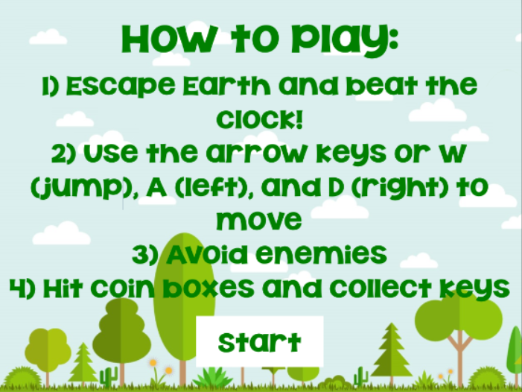*

*The instructions scene displays the goal of the game and the controls for the game, along with the start button. When the start button is clicked, the player is brought to the Level1Scene.*

*Level1 Scene:*

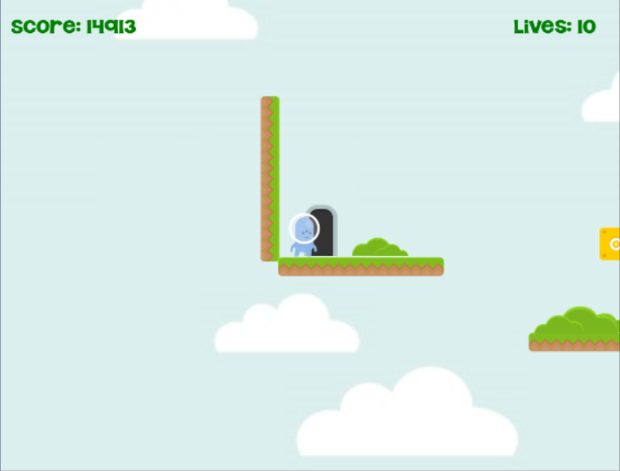

*The Level1 Scene is where the main gameplay starts. The player’s avatar can be moved left, right, and up (jump) to navigate to the exit and/or avoid enemies. Note that this scene may look different depending on the screen size. When the player runs out of lives, s/he reaches the Game Over State. When the player reaches the exit, s/he is brought to the Level2 Scene.*

*Level2 Scene:*

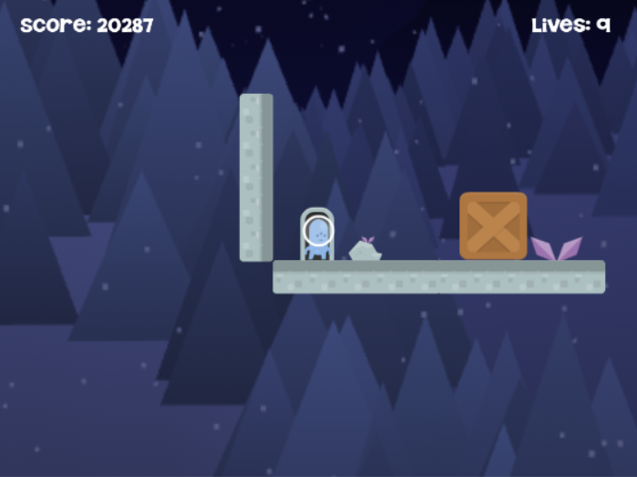

*The Level2 Scene is the second scene in which the main gameplay takes place. As with the Level1 Scene, the player’s avatar can be moved left, right, and up (jump) to navigate to the exit and/or avoid enemies. Note that this scene may look different depending on the screen size. When the player runs out of lives, s/he reaches the Game Over State. When the player reaches the exit, s/he is brought to the Level3 Scene. This level is slightly more difficult than the previous level, and introduces the crate and springboard game objects.*

*Level3 Scene:*

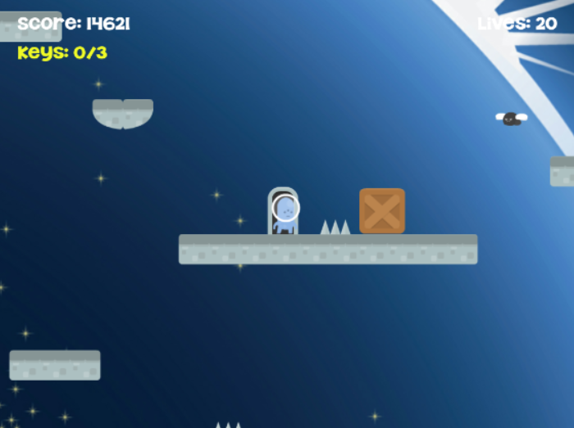

*The Level3 Scene is the final scene in which the main gameplay takes place. As with the Level1 and Level2 Scenes, the player’s avatar can be moved left, right, and up (jump) to navigate to the exit and/or avoid enemies. Note that this scene may look different depending on the screen size. When the player runs out of lives, s/he reaches the Game Over State. When the player reaches the exit, s/he reaches the Game Clear State. This is the most difficult level in the game, and introduces the spikes and key game objects.*

*Game Over/Clear State*

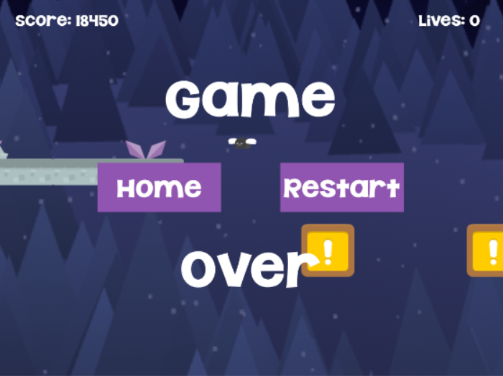

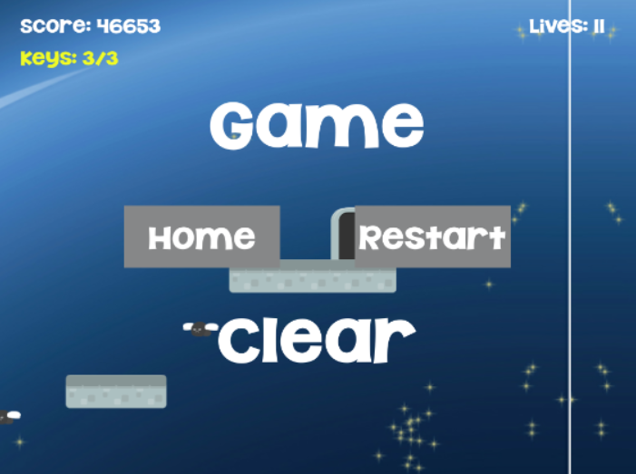

*The Game Over/Clear State shows the enemies continuing to move and the restart button. When the latter is clicked, the player starts the game again from Level1.*

## Characters

*The game’s protagonist is a blue alien with three eyes. It has grown tired of Earth’s poisonous atmosphere and dangerous inhabitants, and tries to find its way back to its spaceship before it changes its mind.*

## Enemies

*Giant black flies, bright pink slimes, and spikes are scattered in ‘convenient’ locations to discourage the blue alien from escaping.*

## Scoring

*The score starts at 15000, and decreases by one for each frame that passes. The score is increased by 1000 each time a golden coin block is hit.*

## Sound Index

|  |  |
| --- | --- |
| *Sound* | *Description* |
| *dead.ogg* | *Played when the blue alien falls off a platform and into the abyss* |
| *forestBgm.ogg* | *Played throughout the Menu and Level1 Scenes* |
| *hurt.ogg* | *Played when the blue alien falls hits an enemy (or spikes)* |
| *jump.ogg* | *Played when the blue alien jumps on/off a platform* |
| *nightBgm.ogg* | *Played throughout the Level2 Scene* |
| *Pickup\_Coin.wav* | *Played when a coin block is hit* |
| *spaceBgm.ogg* | *Played throughout the Level3 Scene* |
| *spring.wav* | *Played when the player lands on a springboard* |

## Art / Multimedia Index

|  |  |  |
| --- | --- | --- |
| *Image* | *Thumbnail* | *Description* |
| *boxAlt* | *F:\OWL (+Centennial)\2016 Centennial\COMP305 - Game Programming\COMP305 Assignment 2\Assets\Sprites\tiles\boxAlt.png* | *Crate that can be moved* |
| *boxCoin* | *C:\Users\User\AppData\Local\Microsoft\Windows\INetCache\Content.Word\boxCoin.png* | *Golden block that can be hit for bonus points* |
| *boxItemAlt* | *C:\Users\User\AppData\Local\Microsoft\Windows\INetCache\Content.Word\boxItemAlt.png* | *Magical block that gives the player a special boost* |
| *bush / plant / plantPurple / rock* | *F:\OWL (+Centennial)\2016 Centennial\COMP305 - Game Programming\COMP305 Assignment 2\Assets\Sprites\decorations\bush.pngF:\OWL (+Centennial)\2016 Centennial\COMP305 - Game Programming\COMP305 Assignment 2\Assets\Sprites\decorations\plant.pngF:\OWL (+Centennial)\2016 Centennial\COMP305 - Game Programming\COMP305 Assignment 2\Assets\Sprites\decorations\plantPurple.pngC:\Users\User\AppData\Local\Microsoft\Windows\INetCache\Content.Word\rock.png* | *Decorations used in the levels* |
| *castleCliffLeft / castleCliffMid* | *C:\Users\User\AppData\Local\Microsoft\Windows\INetCache\Content.Word\castleCliffLeft.pngC:\Users\User\AppData\Local\Microsoft\Windows\INetCache\Content.Word\castleCliffRight.png* | *Used to create moving stone platforms* |
| *castleLeft / castleMid / castleRight* | *F:\OWL (+Centennial)\2016 Centennial\COMP305 - Game Programming\COMP305 Assignment 2\Assets\Sprites\tiles\castleLeft.pngF:\OWL (+Centennial)\2016 Centennial\COMP305 - Game Programming\COMP305 Assignment 2\Assets\Sprites\tiles\castleMid.pngF:\OWL (+Centennial)\2016 Centennial\COMP305 - Game Programming\COMP305 Assignment 2\Assets\Sprites\tiles\castleRight.png* | *Used to create stone platforms* |
| *door\_closedMid / doorClosedTop* | *F:\OWL (+Centennial)\2016 Centennial\COMP305 - Game Programming\COMP305 Assignment 2\Assets\Sprites\tiles\door_closedMid.pngF:\OWL (+Centennial)\2016 Centennial\COMP305 - Game Programming\COMP305 Assignment 2\Assets\Sprites\tiles\door_closedTop.png* | *Locked door* |
| *door\_openMid / door\_openTop* | *F:\OWL (+Centennial)\2016 Centennial\COMP305 - Game Programming\COMP305 Assignment 2\Assets\Sprites\tiles\door_openMid.pngF:\OWL (+Centennial)\2016 Centennial\COMP305 - Game Programming\COMP305 Assignment 2\Assets\Sprites\tiles\door_openTop.png* | *Open door to reach* |
| *flagBlue / flagBlue2 / flagBlueHanging* | *F:\OWL (+Centennial)\2016 Centennial\COMP305 - Game Programming\COMP305 Assignment 2\Assets\Sprites\flags\flagBlue.pngF:\OWL (+Centennial)\2016 Centennial\COMP305 - Game Programming\COMP305 Assignment 2\Assets\Sprites\flags\flagBlue2.pngF:\OWL (+Centennial)\2016 Centennial\COMP305 - Game Programming\COMP305 Assignment 2\Assets\Sprites\flags\flagBlueHanging.png* | *Checkpoint (animated, static)* |
| *flyFly1 / flyFly2* | *F:\OWL (+Centennial)\2016 Centennial\COMP305 - Game Programming\COMP305 Assignment 2\Assets\Sprites\enemy\flyFly1.pngF:\OWL (+Centennial)\2016 Centennial\COMP305 - Game Programming\COMP305 Assignment 2\Assets\Sprites\enemy\flyFly2.png* | *Moving enemy to avoid* |
| *grassCliffLeft/grassCliffRight* | *C:\Users\User\AppData\Local\Microsoft\Windows\INetCache\Content.Word\grassCliffLeft.pngC:\Users\User\AppData\Local\Microsoft\Windows\INetCache\Content.Word\grassCliffRight.png* | *Used to create moving grassy platforms* |
| *grassLeft / grassMid / grassRight* | *F:\OWL (+Centennial)\2016 Centennial\COMP305 - Game Programming\COMP305 Assignment 2\Assets\Sprites\tiles\grassLeft.pngF:\OWL (+Centennial)\2016 Centennial\COMP305 - Game Programming\COMP305 Assignment 2\Assets\Sprites\tiles\grassMid.pngF:\OWL (+Centennial)\2016 Centennial\COMP305 - Game Programming\COMP305 Assignment 2\Assets\Sprites\tiles\grassRight.png* | *Used to create grassy platforms* |
| *hillLarge* | *C:\Users\User\AppData\Local\Microsoft\Windows\INetCache\Content.Word\hill_large.png* | *Used to block off grassy platforms* |
| *keyYellow* | *F:\OWL (+Centennial)\2016 Centennial\COMP305 - Game Programming\COMP305 Assignment 2\Assets\Sprites\keys\keyYellow.png* | *Key to unlock a door* |
| *p2\_jump / p2\_stand / p2\_walk01 / p2\_walk02 / p2\_walk03 / p2\_walk04 / p2\_walk05 / p2\_walk06 / p2\_walk07 / p2\_walk08 / p2\_walk09 / p2\_walk10 / p2\_walk11* | *F:\OWL (+Centennial)\2016 Centennial\COMP305 - Game Programming\COMP305 Assignment 2\Assets\Sprites\player\p2_jump.pngF:\OWL (+Centennial)\2016 Centennial\COMP305 - Game Programming\COMP305 Assignment 2\Assets\Sprites\player\p2_stand.pngF:\OWL (+Centennial)\2016 Centennial\COMP305 - Game Programming\COMP305 Assignment 2\Assets\Sprites\player\p2_walk01.pngF:\OWL (+Centennial)\2016 Centennial\COMP305 - Game Programming\COMP305 Assignment 2\Assets\Sprites\player\p2_walk02.pngF:\OWL (+Centennial)\2016 Centennial\COMP305 - Game Programming\COMP305 Assignment 2\Assets\Sprites\player\p2_walk03.pngF:\OWL (+Centennial)\2016 Centennial\COMP305 - Game Programming\COMP305 Assignment 2\Assets\Sprites\player\p2_walk04.pngF:\OWL (+Centennial)\2016 Centennial\COMP305 - Game Programming\COMP305 Assignment 2\Assets\Sprites\player\p2_walk05.pngF:\OWL (+Centennial)\2016 Centennial\COMP305 - Game Programming\COMP305 Assignment 2\Assets\Sprites\player\p2_walk06.pngF:\OWL (+Centennial)\2016 Centennial\COMP305 - Game Programming\COMP305 Assignment 2\Assets\Sprites\player\p2_walk07.pngF:\OWL (+Centennial)\2016 Centennial\COMP305 - Game Programming\COMP305 Assignment 2\Assets\Sprites\player\p2_walk08.pngF:\OWL (+Centennial)\2016 Centennial\COMP305 - Game Programming\COMP305 Assignment 2\Assets\Sprites\player\p2_walk09.pngF:\OWL (+Centennial)\2016 Centennial\COMP305 - Game Programming\COMP305 Assignment 2\Assets\Sprites\player\p2_walk10.pngF:\OWL (+Centennial)\2016 Centennial\COMP305 - Game Programming\COMP305 Assignment 2\Assets\Sprites\player\p2_walk11.png* | *Player’s avatar (animated)* |
| *slimeWalk1/slimeWalk2* | *C:\Users\User\AppData\Local\Microsoft\Windows\INetCache\Content.Word\slimeWalk1.pngC:\Users\User\AppData\Local\Microsoft\Windows\INetCache\Content.Word\slimeWalk2.png* | *Moving enemy to avoid* |
| *spikes* | *F:\OWL (+Centennial)\2016 Centennial\COMP305 - Game Programming\COMP305 Assignment 2\Assets\Sprites\enemy\spikes.png* | *Static ‘enemy’ to avoid* |